Challenge 2: Emergency Crew Transport

Len Johns Shaji,Tyler Martelon, Aaron Hinkle, Ethan Bush, Celine Cherian

**Overview of Design Criteria**

Design and modeling of an emergency transportation system for an incapacitated crew member during an EVA. This system should be able to propel itself at a constant speed of 4 km/h and only require directional input from an operator. This system should hold onto an incapacitated astronaut and completely immobilize them during transport. The system should weigh no more than 50 lbs. (under earth gravity conditions) and be able to be broken down into pieces of at most 25 lbs. each for transport, additionally it must support up to 243 lbs. of added mass on the system. The system should take advantage of the construction of the xEMU space suit’s design where possible for the transport and immobilization of a crew member. Under the most ideal situation the system overall will not exceed 25 lbs. total to enable an entire system to be carried by a single individual however this is a highly encouraged design goal and not a design requirement.

**Structural Design**

We based the system on a set of tubes fastened with clip-together fasteners. These tubes and fasteners are intended to be stored bundled together and connected to a crew member’s utility belt or thigh. A steel pin in each pipe section secures the pipes within their fasteners and provides a snug fit that partially retains the pipes due to friction. When fully assembled, this makes a roughly 182x70cm rectangular structure on which to secure a crew member.

Securing a crew member to the pipe frame is accomplished by utilizing Beta cloth straps which secure entirely around the PLSS, CHUT, and arms on the upper body, over the knees, and under the thighs and ankles of the crew member. Additionally, there is hardware to mount the hardware pins located on the waist of the xEUV suit to the frame to further secure an individual to the system.

*An early design concept for system frame*

Once a crew member is secured to the frame the operator of the system can then fold out the two passive support wheels and one hub motor-powered propulsion wheel. Folding the wheels out is assisted by areas to insert the removable handlebar to add leverage and more easily get the system onto its wheels, once folded into the correct position these wheels and the sections of pipe they’re connected to will lock into place with a spring-loaded pin.

*CAD model of full frame structure minus straps*

**Material Selection**

As weight and strength are both important factors in this design, the material selection was a quite contentious subject in the design discussion. The biggest need of the design was for a structural material that could:

-Withstand the forces of weight added to the system

-Withstand the lunar environment and its hazards including regolith and solar radiation

-Be lightweight and enable the lightest possible system without sacrificing usability/stability.

With these parameters in mind, we quickly went through multiple options including PEEK plastic, fiberglass, Nomex netting, and others. We narrowed down our search to aluminum and carbon fiber and ended up switching between the two options for some time during the design process, eventually deciding on carbon fiber for the overall structure and aluminum for the fasteners.

Carbon fiber was selected for its excellent strength-to-weight ratio. Being an overall lightweight material with great tensile strength it was a good pick for the overall structure of the frame. While we considered making the fasteners out of carbon fiber as well, we ended up deciding that the forces being exerted on these pieces would probably be too high for it to be practical.

While aluminum was considered for the overall structure it was still too heavy despite its low mass compared to other metals. Rather after opting not to use carbon fiber fasteners a well we decided that using aluminum for the fasteners would be better to handle the forces acting on the fastener pieces.

Other than the structural components the straps were also a major material decision. Given the fact most fabrics aren’t well equipped for the conditions on the moon, we asked advice from some professionals in the space and were suggested to use either beta cloth or nomex fabric. Nomex was a promising prospect but was too heavy and contributed too much to the overall mass for us to consider going forward with. As the only other option was beta cloth and it had acceptable weight we selected it as the strap material.

**Electronics integration**

To enable the system to best be able to propel itself with the lowest weight possible we had to carefully consider the type of electronics that would be utilized. To maintain a speed of 4 km/h on the lunar surface we found we’d need to use a 70-watt motor running off of 24-volt power. In order to supply this motor with energy we opted to utilize a 13000 mAh lithium polymer battery for its power-to-weight ratio which allows a much greater energy density with less mass added to the system. The motor itself is a fully enclosed dust-proof hub motor integrated into the wheel assembly.

In order to control the motion of the system we’re utilizing wireless communication between two ESP32 microcontrollers and a three-position switch. The system has a simple selection between forward, backward, and stopped for motion as it is all it will need, any type of speed adjustment will add points of failure and mass that are not needed for the system’s function.

**Computer-Aided Design work**

As part of this project, we made use of SolidWorks, a CAD software popular among mechanical engineering students at our university. We developed models for each part of the structure and combined them into a full assembly model. The following are images of the model produced.

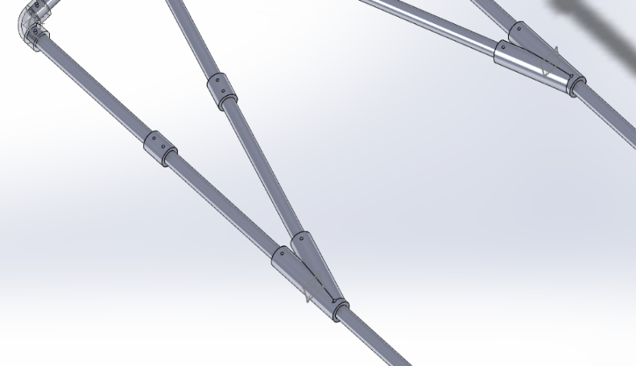

**Cost Analysis**

Below is the compiled cost data for all system components.

